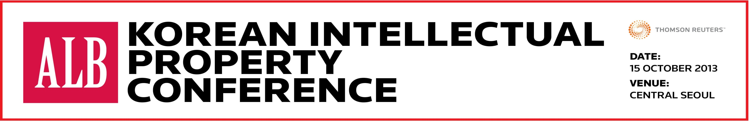
http://www.asianlegalbusinessevents.com/korean-ip-conference/
Date: Tuesday 15 October 2013, 8:50am to 5pm
Venue: Seoul
LIMITED SPACE – RESERVE YOUR EXCLUSIVE PASS NOW
Dear Sir/Madam,
Asia`s leading legal industry publication, Asian Legal Business, with the support of the Korean Fair Trade Commission and the Korean Bar Association, proudly presents the 1st ALB Korean Intellectual Property Conference on October 15 2013 in Seoul and would like extend an exclusive invitation for you to attend this prestigious event.
This unrivalled knowledge-sharing platform offers senior-level corporate counsel, business executives, private practitioners and IP experts closed-door networking and the opportunity to get updated on the most pressing IP management matters in Korea from IP monetisation, online brand protection through to anti-trust issues and dispute resolution.
Our Expert Speakers include
- Yongho Han, Senior Deputy Director, Anti-Monopoly Division, Korea Fair Trade Commission (KFTC)
- Ki-Young Kim, Presiding Judge, Seoul Southern District Court
- Eric Eui-Kwon Kim, General Counsel, Dong-A Socio Holdings (Dong-A Pharmaceutical)
- Jeong-Joong Kim, Vice-President, LG Innotek, President, LES Korea
- Calvin Park, Calvin Park, Senior Director/Legal Counsel, Qualcomm, Incorporated
- Daniel Wooseob Shim, Senior Legal Counsel, IP Legal Team, Samsung Electronics
- Yun-kyung Choi, Senior Manager, Intellectual Management Division, LG Chem Ltd
- Hana Kim, General Counsel, Walt Disney
- Jay Im, Head of International Legal Affairs, CJ E&M Corporation
- Jun S. Park, former Vice-President/General Counsel, Intellectual Property & Legal Affairs Team, Samsung LED Co.
Key Topic Highlights:
- The latest government initiatives combining IP monetisation with competition law compliance
- Korea`s first reverse payment procedure from a leading pharmaceutical company
- Industry strategies to combat online counterfeiting and digital piracy
- IP litigation practices in a Fair, Reasonable, and Non-Discriminatory terms (FRAND) setting
- Patent troll case studies by Korea`s leading technology corporation
For more information, click here for the newly released conference brochure or contact Trang at +65 6870 3711!
Why you should attend:
- Opening GOVERNMENT KEYNOTE by the Korean Fair Trade Commission
- Take away real-life IP case studies by Korean and international healthcare, entertainment and technology conglomerates
- Enjoy networking opportunities with Korea`s top government, judicial representatives and In-House Counsel
- Be part of an interactive panel discussion on the critical role of the In-House Counsel in IP commercialisation and protection
- Join Korea`s ONLY IP Conference dedicated to addressing the crucial interaction between IP and Competition Law
The Early Bird Rate is available now! Register before 20 September, save $200 & pay only $390
Regular Price - $590
Group Price - SAVE AN ADDITIONAL 20% - Register 5 participants from your organisation and the 5th person attends for free
So what are you waiting for? To take up this limited offer, download the registration form and send it back to chuminh.trang@thomsonreuters.com ! We look forward to welcoming you at the event!
Best wishes,
Andrew Smart
Managing Director
Asian Legal Business
Thomson Reuters
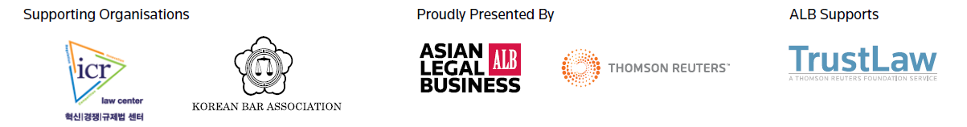
This message and any attachments (the "message") are intended solely for the addressees and are confidential. If you receive this message in error, please delete it and immediately notify the sender.

